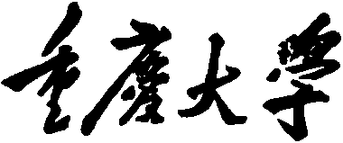


Personal Learning Portfolio

Course： English Academic Writing Teacher： Zhang Mei
Class： 001 Major： CS
Name： Student Number：
Class Time： 2024.02-2024.06
Grade：

Self | Teaching Assistant | Teacher
9

Comments：

Teacher (Signature)
Contents

Styles of research paper
- My learning
- In class

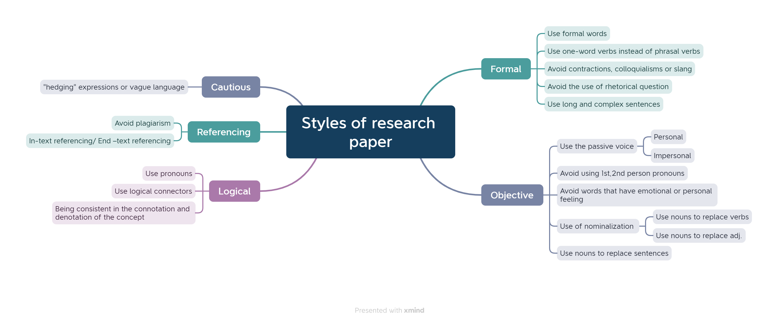
- Learning outcomes
1）In class
1) When I'm writing a paper, I need to be careful not to be too colloquial.
2) When I write my dissertation, I need to pay attention to logical rigor and clear structure.
3) When I write my essay, I need to pay attention to objective descriptions, and most of the time use the third person
2）Out of Class
1) The next time I do Level 6 Listening, I need to read the listening options and have a frame in mind before listening begins.
2) When structuring the body paragraphs, arrange them logically according to the nature of the subject or the type of paper being written.
- My behavior and attitude
1）Out of Class
1.1 Autonomous learning
Offline (memorize vocabulary and listen to CET-6 listening exercises)
1.2 Homework
I completed my English assignment promptly with a diligent and meticulous attitude, ensuring it was not procrastinated until the deadline.
2）In Class
2.1 Individual performance (Take notes promptly and attentively focus during class).
2.2 Cooperation (Actively participate in classroom discussions)
4．Improvement
1）Out of Class
This week, I memorized CET-6 words outside of class and conducted Level 6 listening training, which greatly improved my CET-6 test-taking ability。
2）In Class
In this class, I learned what to pay attention to when writing a paper, including the choice of words, voice, subjective and objective voice, etc.

Contents

Research Methodology
- My learning
- In class
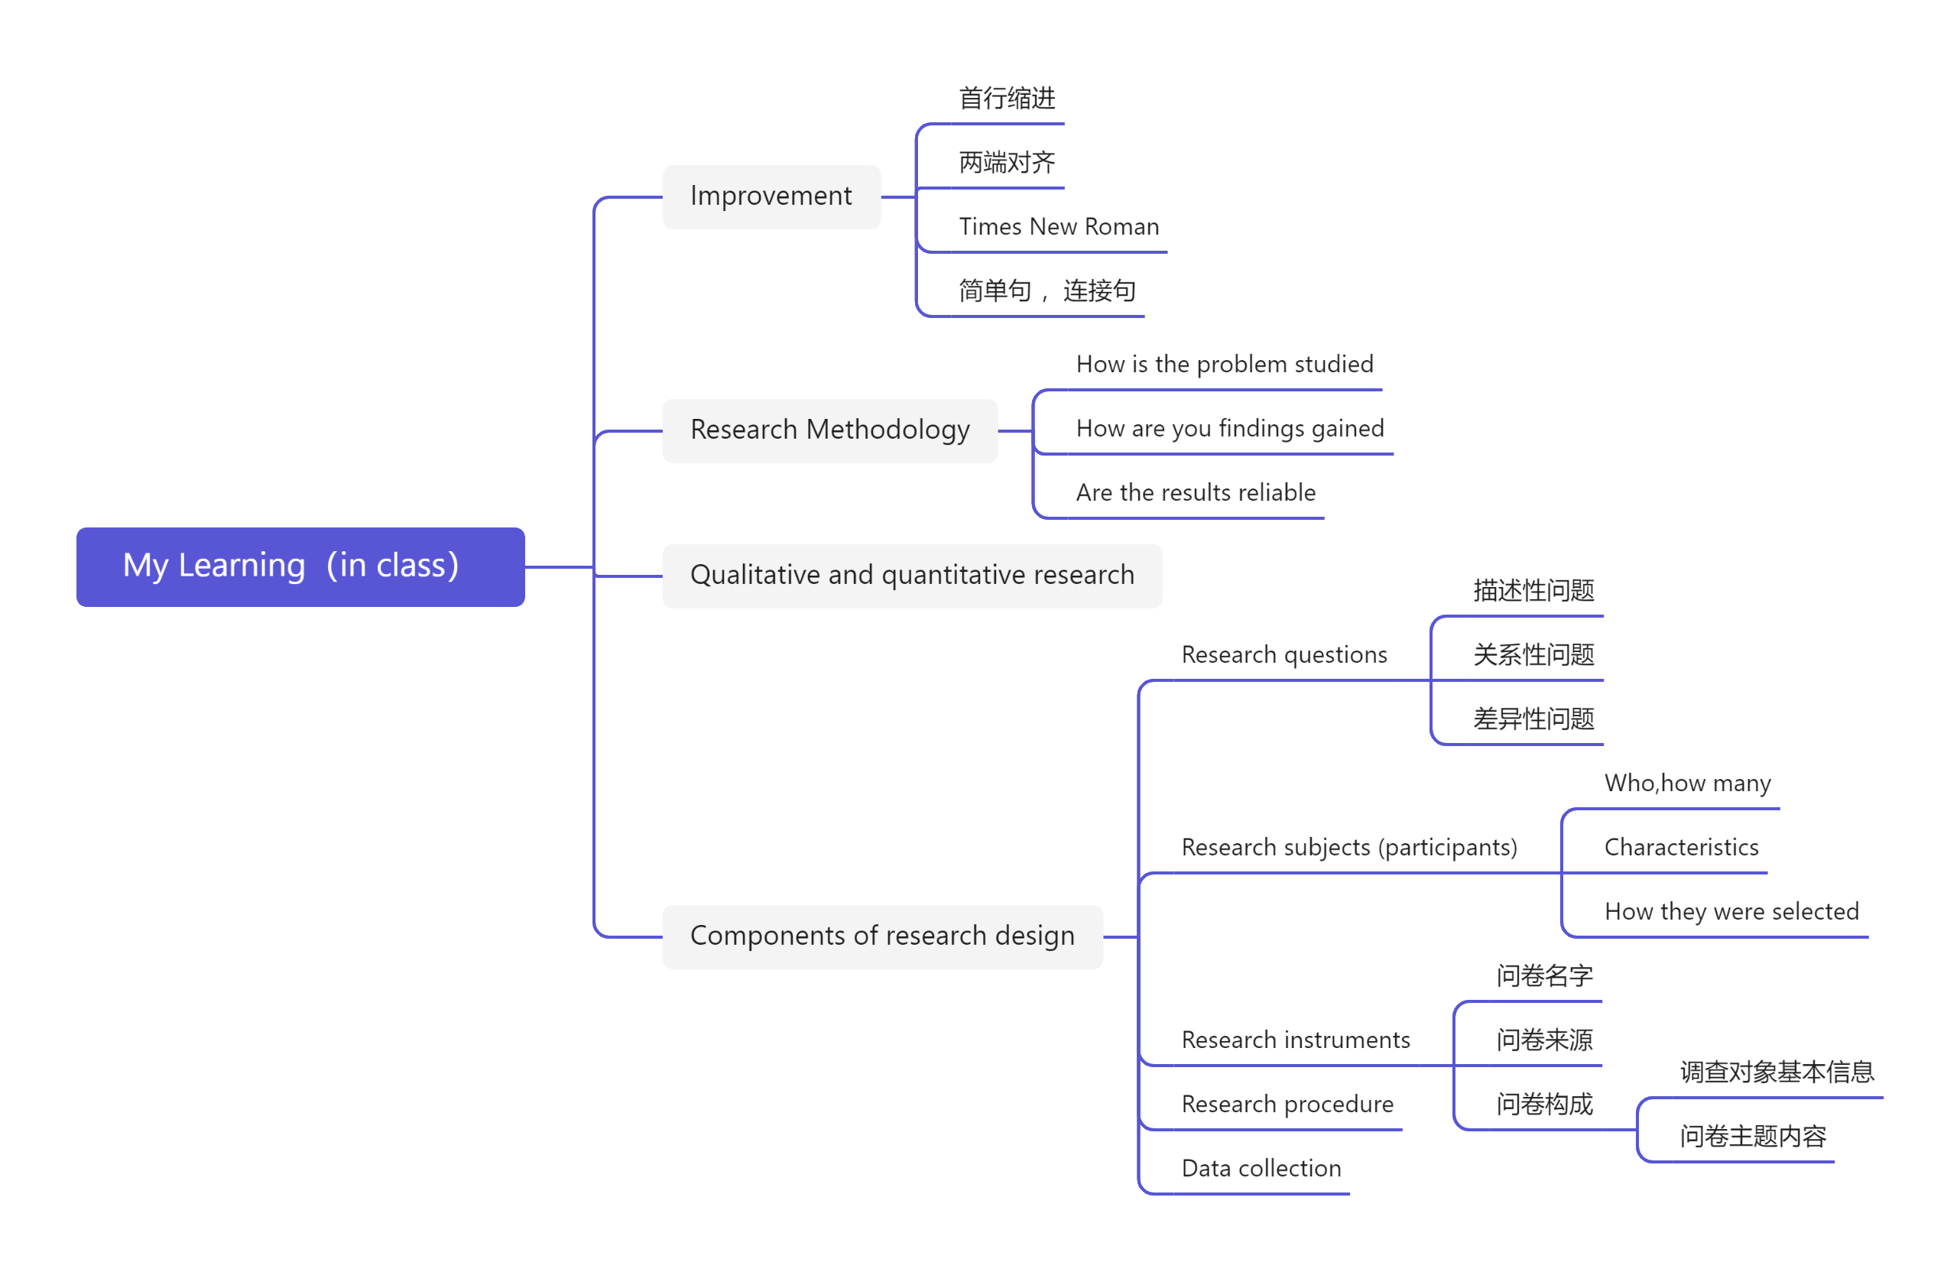
- Out of Class
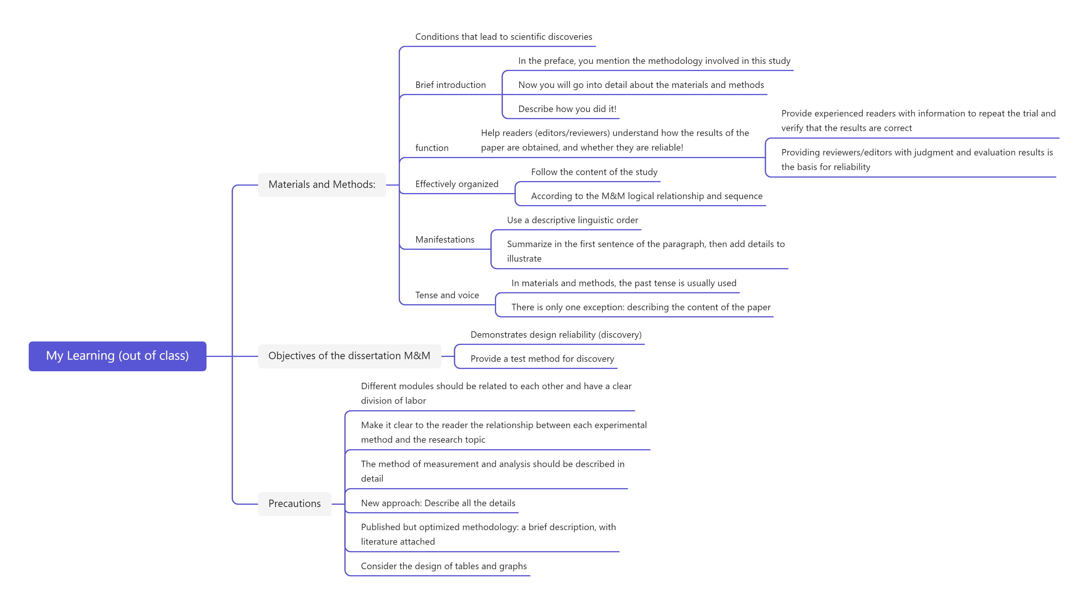
- Learning outcomes
1）In class
1) When I was writing my paper, I knew to use the Times New Roman font, with the first line indented and the ends aligned.
2) The next time I describe a research question, I know that it should be divided into descriptive questions, relational questions, and difference questions.
3) When I'm writing a questionnaire, I should figure out where the question is coming from.
2）Out of Class
1) When I was designing the goal of M&M, I needed a reliable surface design and a test method to be found.
2) When I write materials and methods, I should be careful to use the past tense.
3) When I write the materials and methods, I need to pay attention to this part at all times to help the reader understand how the results of the paper are obtained.
3. My behavior and attitude
1）Out of Class
1.1 Autonomous learning (Online + Offline)
1.1.1 Online (CET-6 online course)
1.1.2 Offline (memorize vocabulary and listen to CET-6 listening exercises)
1.2 Homework
I completed my English assignment promptly with a diligent and meticulous attitude, ensuring it was not procrastinated until the deadline.
1.3 Cooperative learning
2）In Class
2.1 Individual performance (Take notes promptly and attentively focus during class).
2.2 Cooperation (Actively participate in classroom discussions)
4．Improvement
1）Out of Class
Through studying MOOCs, I learned what is the purpose of writing the materials and methods part of a paper, and how to write this part to help readers understand how the results of the paper are obtained.
2）In Class
In this class, I learned about the main components of the reasearch methodology, and understood the precautions and improvements in thesis writing.

